**MongoDB Day 1**

1. Find all the information about each products:

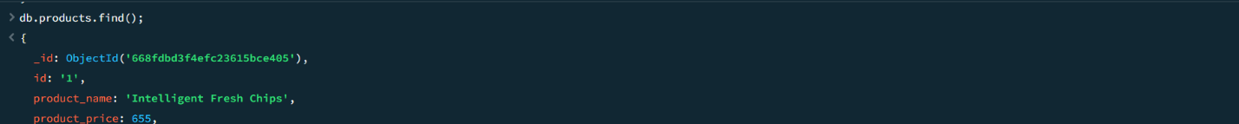

db.products.find();

1. Find the product price which are between 400 to 800

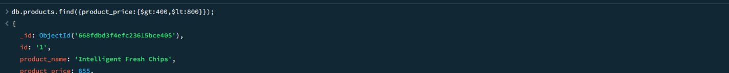

db.products.find({product_price:{$gt:400,$lt:800}});

1. Find the product price which are not between 400 to 600

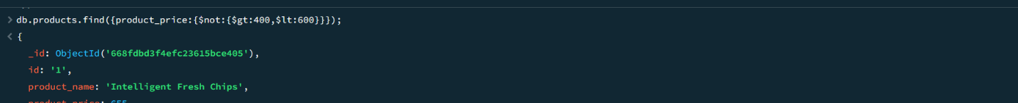

db.products.find({product_price:{$not:{$gt:400,$lt:600}}});

1. List the four product which are greater than 500 in price

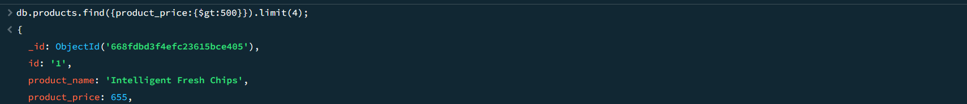

db.products.find({product_price:{$gt:500}}).limit(4);

1. Find the product name and product material of each products

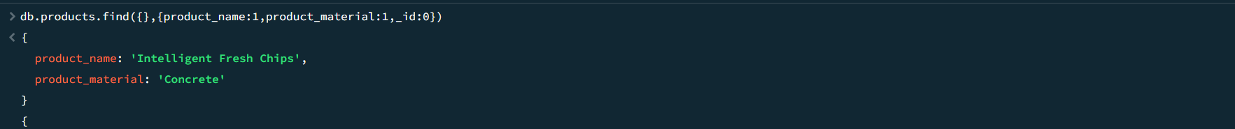

db.products.find({},{product_name:1,product_material:1,_id:0});

1. Find the product with a row id of 10

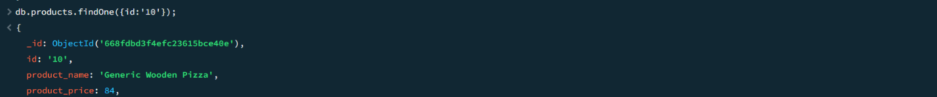

db.products.findOne({id:’10’});

1. Find only the product name and product material

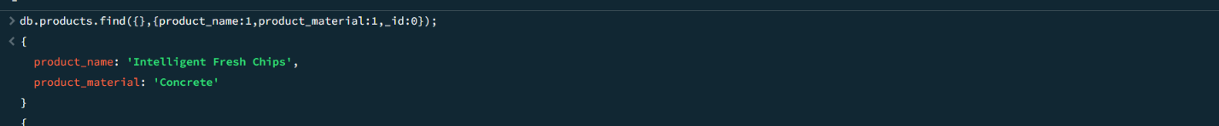

db.products.find({},{product_name:1,product_material:1,_id:0});

1. Find all products which contain the value of soft in product material

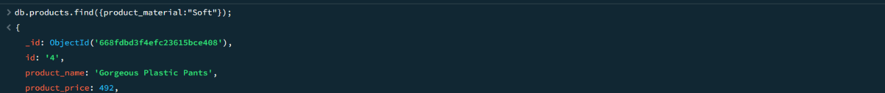

db.products.find({product_material:”Soft”});

1. Find products which contain product color indigo  and product price 492.00

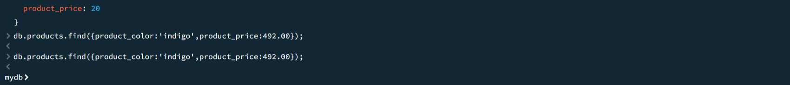

db.products.find({product_color:’indigo’,product_price:492.00});

(or)



db.products.find($and:[{product_color:’indigo’},{product_price:492.00}]});

1. Delete the products which product price value are 28



db.products.deleteMany({product_price:28});